A Comparative Study of 4 AI Models used to Research Ellen White’s Writings

Case Study: The Danger of AI Hallucination in Sacred Text Research
Consider a pastor preparing a Sabbath sermon on the relationship between faith and works. Pressed for time, they turn to a general-purpose AI model and ask: “What is the best statement from Ellen G. White about faith and works?” The model responds confidently, providing what appears to be a theologically sound quotation: “We are not saved by obedience, but we are saved unto obedience.” It attributes this to Steps to Christ. The pastor, trusting the response, incorporates it into his sermon notes and later publishes it on the church blog.
The problem: that quotation does not exist in Ellen White’s writings at all. It is a complete hallucination — a plausible-sounding fabrication generated by the AI with full confidence but with no reliable source. The actual Ellen White statement on this subject, drawn from Patriarchs and Prophets, reads: “Man is to be saved by faith, not by works; yet his faith must be shown by his works.” The theological meaning is related but the wording, source, and reference are entirely different. This is precisely the scenario this study was designed to expose. When AI models hallucinate quotations from Ellen White, they do not merely introduce minor inaccuracies — they risk corrupting the doctrinal foundation of sermons, Bible studies, Sabbath School lessons, evangelistic outreach, and academic research.
The following case study of reviewing seven common questions relating to Ellen White illustrates a critical analysis that not all AI tools are equal when it comes to handling sacred or specialized text. Each of the seven questions were designed specifically to test each model’s ability to retrieve accurate quotations, correct source references, and faithfully represent Ellen White’s theology across a range of topics, from the Trinity and salvation, to the Sabbath, tithing, and the immutability of God’s law.

Introduction to Researching EGW Writings Using AI
The emergence of artificial intelligence as a research tool has opened new possibilities for theological scholarship, biblical study, and the exploration of denominational literature. For Seventh-day Adventists and scholars of Adventist history, the writings of Ellen G. White represent one of the most extensive bodies of prophetic and devotional literature produced within any Protestant tradition — encompassing more than 100,000 pages of books, letters, manuscripts, and periodical articles. Navigating this corpus with accuracy, contextual faithfulness, and doctrinal precision has long required years of dedicated study. The question now before researchers, pastors, and educators is whether current AI language models can serve as reliable assistants to accomplish that task.
This seminar presents a structured comparative evaluation of four AI models — EGW Writings AI, Anthropic Claude Sonnet 4.6, Google Gemini 3.5 Flash, and OpenAI ChatGPT 5.5. Each were tested against seven theological questions drawn directly from Ellen White’s published works.
1. Statements placing the Holy Spirit as part of the Trinity
2. Best statement on faith and works
3. Cautions about the dangers of sin
4. Whether EGW claimed her writings are authoritative for the church
5. Importance of worshipping on the Sabbath day
6. Whether Christians should give a tenth of their income in tithe
7. What EGW says about people attempting to change God's law
Each model was asked to provide quotations, references, and contextual statements from her writings. The results were then verified against authoritative primary sources available on EGWWritings.org. Accuracy was scored on a percentage basis per question, with a composite total calculated across all seven questions.

-----------------------------------------------------------------------------------------------------------------
Question 1: Provide statements from Ellen White that places the holy spirit as part of the trinity?
EGW Writings AI: Score 100% (5 of 5 correct)
“The Holy Spirit has a personality, else He could not bear witness to our spirits and with our spirits that we are the children of God. He must also be a divine person, else He could not search out the secrets which lie hidden in the mind of God. ‘For what man knoweth the things of a man, save the spirit of man which is in him? even so the things of God knoweth no man, but the Spirit of God.’ Manuscript 20, 1906.” —Evangelism, 616.6

Anthropic Anthropic Claude Sonnet 4.6: Score 100% (All 5 Quotes were accurate)
Claude Sample Quote: “Sin could be resisted and overcome only through the mighty agency of the third person of the Godhead.” —The Desire of Ages, p. 671
Note: Latest Claude advanced model Opus 4.7 no longer provides information from copyrighted sources such as EGWWritings.org. It will only provide search links.

Google Gemini 3.5 Flash: Score 50% (Only 2 out of the 4 quotes were accurate)
Gemini Misquote with Incorrect Reference - 1: “The Holy Spirit is a person, for He beareth witness with our spirits that we are the children of God... The Holy Spirit is the Comforter, in the name of Christ. He personifies Christ, yet is a distinct personality.”— Manuscript 93, 1893
EGW Correct Quote - 1: “The Holy Spirit is a person; for He beareth witness with our spirits that we are the children of God. Manuscript 20, 1906, par. 31
“The Holy Spirit has a personality, else He could not bear witness to our spirits and with our spirits that we are the children of God. He must also be a divine person…” Manuscript 20, 1906, par. 32
Gemini Allusion to Incorrect Reference - 1: “The Father, the Son, and the Holy Ghost, powers eternal and infinite, are to be safely trusted.” —The Review and Herald, May 17, 1906
EGW Correct Quote - 2: “Keep yourselves where the three great powers of heaven—the Father, the Son, and the Holy Spirit—can be your efficiency. These powers work with the man who gives himself unreservedly to God, heart and soul, and mind and strength. —Letter 102, 1903, par. 11
OpenAI ChatGPT 5.5: Score 66.6% (4 out of 6 quotes were correct)
ChatGPT Incorrect Reference - 1: The Father, the Son, and the Holy Spirit, the three holy dignitaries of heaven, have declared that they will strengthen men to overcome the powers of darkness. —Manuscript Releases, Vol. 7, p. 267
EGW Correct Quote - 1: “The Father, the Son, and the Holy Spirit, the three holy dignitaries of heaven, have declared that they will strengthen men to overcome the powers of darkness. —Manuscript 92, 1901, par. 26
ChatGPT Modified Quote with Allusion to Incorrect Reference - 2: “The three highest powers in heaven are working with every sanctified effort in accordance with God’s plans.” —The Southern Watchman
EGW Correct Quote - 2: In the great closing work we shall meet with perplexities that we know not how to deal with, but let us not forget that the three great powers of heaven are working, that a divine hand is on the wheel, and that God will bring His purposes to pass. —Manuscript 118, 1902, par. 11
-----------------------------------------------------------------------------------------------------------------
Question 2: What is the best statement from Ellen G. White about faith and works?
EGW Writings AI: Score 100% (5 of 5 correct)
“As sons of God we are partakers of the divine nature. We know what true light is, and know the power of the grace of Christ. We have the faith that works by love and purifies the soul.” Manuscript 6, 1895, par. 13

Anthropic Claude Sonnet 4.6: Score 0% (The provided quote was a 100% hallucination answer)
Claude Hallucination: “We are not saved by obedience, but we are saved unto obedience.” —Steps to Christ
EGW Correct Quote: “Man is to be saved by faith, not by works; yet his faith must be shown by his works. —Patriarchs and Prophets, 279.1
Gemini 3.5 Flash: Score 50% (Gemini got half the quote correct. But used the wrong reference.)
Gemini Modified Quote with an Allusion to Incorrect Reference: “Let no man present the idea that man has little or nothing to do in the great work of overcoming; for God does nothing for man without his cooperation. Neither say that after you have done all you can on your part, Jesus will help you. Christ has said, ‘Without me ye can do nothing.’ From first to last man is to be a co-worker with God. Unless the Divine Spirit works upon the human heart, we cannot take a single step heavenward. The work of the Spirit is to give man power to act, but not to dispense with his action. Man is to work with the power given him from above.” —Faith and Works, p. 57 (Manuscript 13, 1890)
EGW Correct Quote: “Let no one present the idea that man has little or nothing to do in the great work of overcoming, for God does nothing for man without his co-operation. Neither say that after you have done all you can on your part, Jesus will <then come in and> help you. Christ has said, “Without me ye can do nothing.” [John 15:5.] From first to last man is to be a laborer together with God. Unless the Holy Spirit works upon the human heart, at every step we shall stumble and fall.
“Man’s efforts <alone> are nothing but worthlessness, but co-operation with Christ means a victory. Of ourselves we have no power to repent of sin. Unless we accept divine aid, we cannot take the first steps toward the Saviour.” —Manuscript 26a, 1892, par. 18, 19
Open AI Chat GPT 5.5: Score 95% (Slight modification of quote)
ChatGPT Slight Modification: “We do not earn salvation through our obedience; for salvation is the free gift of God, to be received by faith. But obedience is the fruit of faith.”—Steps to Christ, 61
EGW Correct Quote: “We do not earn salvation by our obedience; for salvation is the free gift of God, to be received by faith. But obedience is the fruit of faith.”—Steps to Christ, 61.1
-----------------------------------------------------------------------------------------------------------------
Question 3: What does Ellen White caution us about the dangers of sin?
EGW Writings AI: Score 100% (5 of 5 correct)
The tendency of sin is to destroy truth and integrity. Entertained in the heart, sin destroys piety, equity, compassion, and genuine love…. Instead of God’s patience hardening the sinner to continual transgression, it should lead him to determine to seek God’s forgiveness, in order that the figures standing against his account in the heavenly record may be canceled. —Manuscript 55, 1902, par. 2, 3

Anthropic Claude Sonnet 4.6: Score 33.3% (Only 1 of 3 quotes was correct.)
Claude Hallucination with Allusion to Incorrect Reference – 1: “Small sins, if cherished, will in time develop into greater ones; the heart becomes hardened by degrees, until the sinner loses all sense of the heinousness of his course.” —Testimonies for the Church, vol. 4
EGW Correct Quote – 1: “The small sins will swell into the greater sins. Impure thoughts, private, impure actions, unrefined, low, and sensual thoughts and actions in the marriage life, the giving of loose reins to the baser passions under the marriage vow, will lead to every other sin, the transgression of all the commandments of God…. For all the natural weaknesses Jesus has made ample provision, that they may be overcome through His grace. If not overcome, the weakness will become a tyrant, a conqueror, to overcome them, and the heavenly light will become beclouded and extinguished.” —Testimonies on Sexual Behavior, Adultery, and Divorce, p. 90.3 - 91.1
Claude Misquote and incorrect reference – 2: “Every || indulgence of that sin strengthens the soul’s aversion to God. The seed sown is developing a harvest of its own kind.” —The Great Controversy
EGW Correct Quote – 2: The Claude quote was a synthesis of the following two modified quotes taken from two completely different sources:
“Every sinful indulgence strengthens the soul’s aversion to God.” —Steps to Christ, 34.1
“The seed sown will produce a harvest of its kind.” —Manuscript 104, 1898, par. 30
Google Gemini 3.5 Flash: Score 50% (2 of 4 quotes were completely correct)
Gemini Quote Mashup - 1, combines two quotes to one reference:
A. “Familiarity with sin will cause it to appear less repulsive... B. “The senses of many are benumbed by the indulgence of appetite and by familiarity with sin.” —From Here to Forever, p. 313
EGW Correct Part A: “Familiarity with sin will cause it to appear less repulsive.” —From Here to Forever, p. 313.4
EGW Correct Part B: “The senses of many are benumbed by the indulgence of appetite and by familiarity with sin.” Testimonies for the Church, vol. 3, p. 476.2
Gemini Incorrect Page Reference - 2: “Man is doing the greatest injury and injustice to his own soul when he thinks and acts contrary to the will of God.” —Steps to Christ, p. 18
EGW Correct Reference Page - 2: “Man is doing the greatest injury and injustice to his own soul when he thinks and acts contrary to the will of God.” —Steps to Christ, p. 46.2
OpenAI ChatGPT 5.5: Score 60% (3 out of the 5 provided quotes were misquoted)
ChatGPT Hallucination Mashup - 1: “It is sin that darkens our minds and weakens our perceptions, so that we can less and less appreciate God.” —The Ministry of Healing
EGW Correct Quote - 1: It is sin that darkens our minds and dims our perceptions. As sin is purged from our hearts, the light of the knowledge of the glory of God in the face of Jesus Christ, illuminating His word and reflected from the face of nature, more and more fully will declare Him “merciful and gracious, long-suffering, and abundant in goodness and truth.” Exodus 34:6 —The Ministry of Healing, 464.6
“If God’s people neglect the privileges which he has provided for them to become strong in him, they will grow weaker and weaker and have less and less desire to consecrate all to him’. —The Review and Herald, August 15, 1882, par. 1
ChatGPT Hallucination with Allusions - 2: “There are many who excuse their defects of character because they commit no outward sin; but these defects are offensive to God.”—Christ’s Object Lessons
EGW Correct Quote - 2: All these expect to be saved by Christ’s death, while they refuse to live His self-sacrificing life. They extol the riches of free grace, and attempt to cover themselves with an appearance of righteousness, hoping to screen their defects of character; but their efforts will be of no avail in the day of God. —Christ’s Object Lessons, 316.1
“The righteousness of Christ will not cover one cherished sin. A man may be a law-breaker in heart; yet if he commits no outward act of transgression, he may be regarded by the world as possessing great integrity. But God’s law looks into the secrets of the heart. Every act is judged by the motives that prompt it. Only that which is in accord with the principles of God’s law will stand in the judgment.” —Christ’s Object Lessons, 316.2

ChatGPT Misquote with Allusion- 3: “The wages of sin is death. But God gives life through Jesus Christ.” —Patriarchs and Prophets
EGW Correct Quote - 3: If the law could be changed, man might have been saved without the sacrifice of Christ; but the fact that it was necessary for Christ to give His life for the fallen race, proves that the law of God will not release the sinner from its claims upon him. It is demonstrated that the wages of sin is death. —Patriarchs and Prophets, 70.1

-----------------------------------------------------------------------------------------------------------------
Question 4: Does Ellen White claim that her writings are to be considered an authoritative source for the Adventist church?
EGW Writings AI: Score 100% (5 of 5 correct)
“I have written many books, and they have been given a wide circulation. Of myself, I could not have brought out the truths in these books, but the Lord has given me the help of His Holy Spirit. These books, giving the instruction that the Lord has given me during the past sixty years, contain light from heaven and will bear the test of investigation.” —Letter 55, 1905, par. 5
Anthropic Claude Sonnet 4.6: Score 60% (3 out of the 5 quotes were incorrect)
Claude Misquote - 1: “I am presenting to you that which the Lord has presented to me. I do not write one article in the paper expressing merely the opinion of Sister White.”
EGW Correct Quote - 1: “I am presenting to you that which the Lord has presented to me. I do not write one article in the paper, expressing merely my own ideas.” —Letter 206, 1906, par. 25
Claude Hallucination attributing a non-Ellen White Quote to Her - 2: “Her writings are a continuing and authoritative source of truth which provide for the church comfort, guidance, instruction, and correction.” —The Truth About the White Lie
(Note: Quote does appears in EGWWritings.org but in the Reference Collection.)
Claude Hallucination attributing a non-Ellen White Quote to Her - 3: “Little heed is given to the Bible, and the Lord has given a lesser light to lead men and women to the greater light” —The Gift of Prophecy
(Note: Quote does appears in EGWWritings.org but in the Reference Collection.)

Google Gemini 3.5 Flash: Score 66% (Only 2 of 3 quotes were correct)
Gemini Mashup of Two Paragraphs without Ellipses and Incorrect Reference:
“Yet now when I send you a testimony of warning and reproof, many of you declare it to be merely the opinion of Sister White. You have thereby insulted the Spirit of God. || I do not write one article in the paper expressing merely my own ideas. They are what God has opened before me in vision.” —Selected Messages, Book 1
EGW Correct Quotes - 1: “Yet now when I send you a testimony of warning and reproof, many of you declare it to be merely the opinion of Sister White. You have thereby insulted the Spirit of God.” —Review and Herald, August 30, 1906, par. 13
“In these letters which I write, in the testimonies I bear, I am presenting to you that which the Lord has presented to me. I do not write one article in the paper, expressing merely my own ideas. They are what God has opened before me in vision—the precious rays of light shining from the throne...” —Review and Herald, August 30, 1906, par. 14

OpenAI ChatGPT 5.5: Score 33.3% (1 out of 3 provided quotes were misquoted)
ChatGPT Misquote: “The Lord has seen fit to give me a view of the wants and errors of His people... The testimony is of the Spirit of God.” —Testimonies for the Church, volume 5, p. 661
EGW Quote Comparison: “The Lord has seen fit to give me a view of the needs and errors of His people. Painful though it has been to me, I have faithfully set before the offenders their faults and the means of remedying them.... Thus has the Spirit of God pronounced warnings and judgments, withholding not, however, the sweet promise of mercy.” —Testimonies for the Church, volume 5, p. 661.2

-----------------------------------------------------------------------------------------------------------------
Question 5: What statements from Ellen White show the importance of worshipping on the Sabbath day?
EGW Writings AI: Score 100% (5 of 5 correct)
“The importance of the Sabbath as the memorial of creation is that it keeps ever present the true reason why worship is due to God”—because He is the Creator, and we are His creatures. “The Sabbath therefore lies at the very foundation of divine worship, for it teaches this great truth in the most impressive manner, and no other institution does this.” —The Great Controversy, 437.2
Anthropic Claude Sonnet 4.6: Score 66.6% (4 of 6 quotes were correct.)
Claude Quote and Allusion to Two Different Passages with Incorrect Reference:
[Part A] “The Sabbath is a sign between God and His people… [Part B] Those who keep the Sabbath holy are thereby giving evidence that they are the loyal subjects of heaven.” — Testimonies for the Church, Vol. 6, p. 349
EGW Correct Quote, Part A: “The Sabbath is a sign between God and His people. —Testimonies for the Church, Vol. 7, p. 122.1
EGW Correct Quote, Part B: “The observance of the Sabbath, the seventh day by God’s people, is the sign to the world that they are linked to the God of heaven as His loyal subjects” —The Signs of the Times, Nov. 22, 1899
Claude Misquote: “On Friday let the preparation for the Sabbath be completed. Let the clothing be prepared, let the food be cooked, let every duty that can be done be finished, that upon the Sabbath there may be no care, no work, but that the time may be given to worship and holy meditation.” —Child Guidance, p. 528
EGW Quote Comparison: “On Friday let the preparation for the Sabbath be completed. See that all the clothing is in readiness, and that all the cooking is done. Let the boots be blacked, and the baths be taken. It is possible to do this. If you make it a rule, you can do it. The Sabbath is not to be given to the repairing of garments, to the cooking of food, to pleasure seeking, or to any other worldly employment. Before the setting of the sun, let all secular work be laid aside, and all secular papers be put out of sight. Parents, explain your work and its purpose to your children, and let them share in your preparation to keep the Sabbath according to the commandment.” —Child Guidance, p. 528.2
Google Gemini 3.5 Flash: Score 75% (4 of 5 quotes matched)
Gemini Slight Misquote - 1: “The Sabbath is the golden clasp that unites God and His people.” —Testimonies for the Church, vol. 6, p. 351
EGW Quote Comparison - 1: “The Sabbath is a golden clasp that unites God and His people.” —Testimonies for the Church, vol. 6, p. 351.6
OpenAI ChatGPT 5.5: Score 33.3% (2 out of the 6 quotes used incorrect references)
ChatGPT Incorrect Reference 1: “The sign, or seal, of God is revealed in the observance of the seventh-day Sabbath, the Lord’s memorial of creation.” —The Great Controversy, p. 640
EGW Quote Comparison 1: “The sign, or seal, of God is revealed in the observance of the seventh-day Sabbath, the Lord’s memorial of creation.” —Testimonies for the Church, vol. 8, 117.3
ChatGPT Incorrect Reference 2: “The importance of the Sabbath as the memorial of creation is that it keeps ever present the true reason why worship is due to God—because He is the Creator, and we are His creatures.” —Patriarchs and Prophets, p. 336
EGW Quote Comparison 2: “The importance of the Sabbath as the memorial of creation is that it keeps ever present the true reason why worship is due to God—because He is the Creator, and we are His creatures.” —The Great Controversy, 437.2

-----------------------------------------------------------------------------------------------------------------
Question 6: Does Ellen White say I should give my Lord a tenth of my income?
EGW Writings AI: Score 100% (5 of 5 correct)
“The Lord calls for His tithe to be given in to His treasury. Strictly, honestly, and faithfully, let this portion be returned to Him. Besides this, He calls for your gifts and offerings. No one is compelled to present his tithe or his gifts and offerings to the Lord. But just as surely as God’s word is given to us, just so surely will He require His own with usury at the hand of every human being.” —Counsels on Stewardship, p. 82.4
Anthropic Claude Sonnet 4.6: Score 100% (6 of 6 quotes correct.)
Claude top quote: “He claims as His just due a tenth of their income, be it large or small; and those who withhold this, commit robbery toward Him, and cannot expect His prospering hand to be with them.” —Gospel Workers
Google Gemini 3.5 Flash: Score 66% (1 out of the 3 quotes were correct)
Gemini Flipped Order of Sentences: Part B, “The tithe is the Lord’s; and He bids us return to Him that which is His own... Part A, This is a matter of simple honesty.” —Education, p. 139
EGW Correct Quote: “This is a matter of simple honesty. The tithe is the Lord’s; and He bids us return to Him that which is His own.” —Education, p. 139
OpenAI ChatGPT 5.5: 1. Score 66.6% (Only 2 of the 3 quotes were accurate and gave the correct reference)
Chat GPT Misquote and Incorrect Reference: “The Lord claims the tithe as His own, and it should ever be regarded as a sacred reserve, to be placed in His treasury for the benefit of His cause.”— Counsels on Stewardship, p. 95
EGW Quote Comparison: God has made ample provision for this work. He intends that the ministry of the gospel shall be fully sustained. He claims the tithe as his own, and it should ever be regarded as a sacred reserve, to be placed in his treasury for the benefit of his cause, for the advancement of his work, for sending his messengers into “regions beyond,” even to the uttermost parts of the earth. —The Review and Herald, December 8, 1896, par. 3

-----------------------------------------------------------------------------------------------------------------
Question 7: What does Ellen White say about God’s law being changed by men.
EGW Writings AI: Score 100% (5 of 5 correct)
Anthropic Claude Sonnet 4.6: Score 100% (Only 6 of 6 quotes correct.)
Claude Top Quote: “The papacy has attempted to change the law of God. The second commandment, forbidding image worship, has been dropped from the law, and the fourth commandment has been so changed as to authorize the observance of the first instead of the seventh day as the Sabbath.” —The Great Controversy
Google Gemini 3.5 Flash: Score 100% (3 of 3 quotes correct)
Gemini Top Quote: “I saw that the Sabbath commandment was not nailed to the cross. If it was, the other nine commandments were; and we are at liberty to break them all, as well as to break the fourth. I saw that God had not changed the Sabbath, for He never changes. But the pope had changed it from the seventh to the first day of the week; for he was to change times and laws.” —Early Writings, p.32
OpenAI ChatGPT 5.5: Score 60% (Only 3 of the 5 quotes provided were correct)
ChatGPT Hallucination - 1: “Men cannot with impunity set aside one command of God and obey another. The authority of God is above every earthly authority.” —Patriarchs and Prophets, p. 634
EGW Quote Comparison: Men cannot with impunity trample upon the word of God. The meaning of this fearful denunciation is set forth in the closing chapter of the Revelation: “I testify unto every man that heareth the words of the prophecy of this book, If any man shall add unto these things, God shall add unto him the plagues that are written in this book.” —The Great Controversy, 268.1
ChatGPT Misquote - 2: “Not a jot or tittle of the law has been changed; not a precept has been abolished.” —Thoughts From the Mount of Blessing, p. 48
EGW Quote Comparison 2: “Not one command has been annulled, not a jot or tittle has been changed.” —Thoughts From the Mount of Blessing, p. 50.2
ChatGPT Allusion to a Quote with an Incorrect Reference: “The law of God is immutable; therefore He could not abolish one precept of His law in order to save fallen man.” —The Faith I Live By, p. 76
EGW Quote Comparison: “The Lord did not change one precept of his law, in order to meet man in his fallen condition. Had he done this in any period of the history of the world, Satan would have gained all that he asked in heaven,—a change of God’s law. But in order to meet its claims, the Lord made an offering for sin, in the person of Jesus Christ, thus demonstrating to the world the immutability of his law. While he expressed his love for men, in giving his Son to die for them, he declared that its divine statutes cannot be changed or abolished.” —The Youth’s Instructor, January 21, 1897, par. 7
Fig. 1: Total Accuracy Graph of Scores by AI Model for all 7 Questions.
AI Model | Q1 | Q2 | Q3 | Q4 | Q5 | Q6 | Q7 | Total %
EGW Writings AI | 100% | 100% | 100% | 100% | 100% | 100% | 100% | 100.0%
Claude Sonnet 4.6 | 100% | 0% | 33.3% | 60% | 66.6% | 100% | 100% | 65.7%
Gemini 3.5 Flash | 50% | 50% | 50% | 66% | 75% | 66% | 100% | 65.3%
ChatGPT 5.5 | 66.6% | 95% | 60% | 33.3% | 33.3% | 66.6% | 60% | 59.3%
* Total % = average of all 7 question scores per model, as reported in the document

Fig. 2: Accuracy Scores of Each Model for all 7 Questions
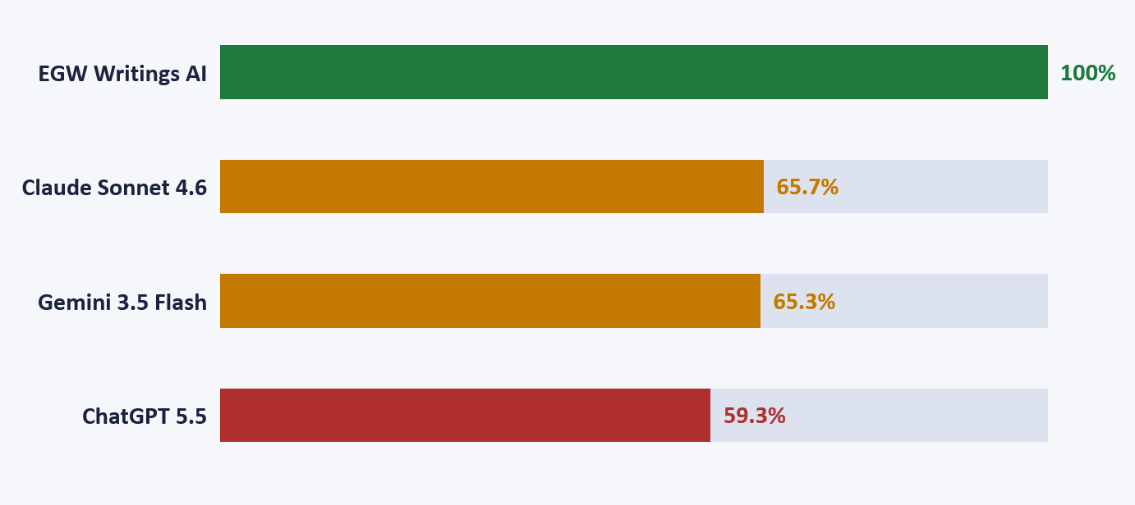
Fig. 3: Bar chart showing the accuracy scores for all four AI models across all seven questions about Ellen White's writings.
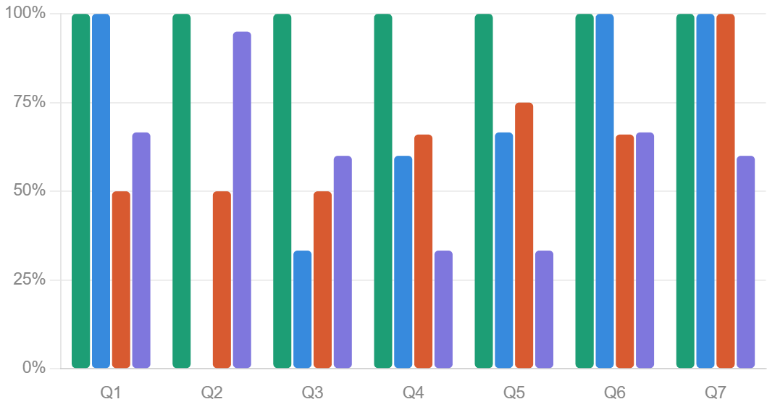

Fig. 4: Pie chart totaling each models accuracy across all 7 questions.
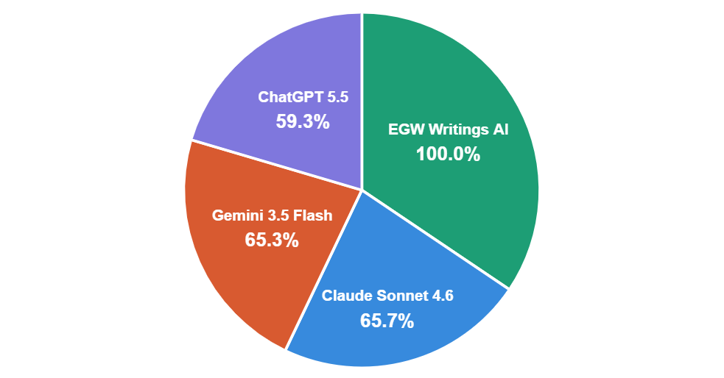
Comparison Study summary of each model
This study set out to answer a straightforward question: can artificial intelligence top AI models be trusted as a research tool for studying the writings of Ellen G. White? The answer, as the data reveals, depends entirely on which AI model is used — and the differences between models are far from trivial. Across seven theological questions, the four models tested produced results that ranged from flawless accuracy to complete fabrication. Below is a concluding assessment of each model, followed by a final recommendation.

1. EGW Writings AI — Total Score: 100%
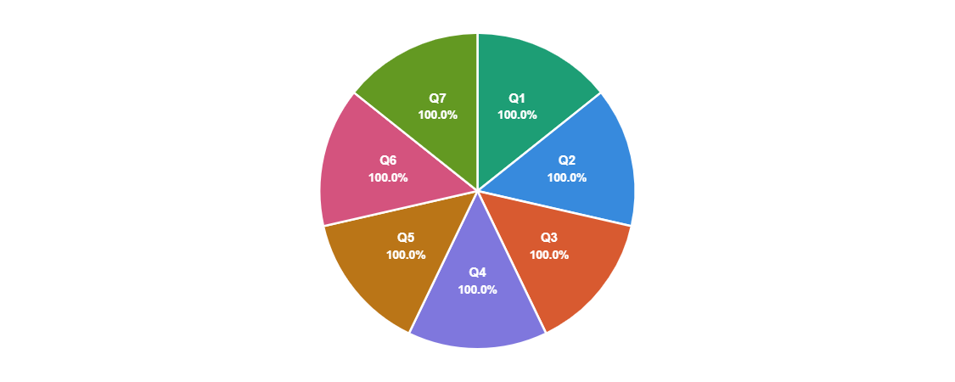
EGW Writings AI achieved a perfect score of 100% across all seven questions — the only model in this study to do so. This is not surprising given that it was purpose-built to search, retrieve, and present content exclusively from the verified Ellen White corpus housed at EGWWritings.org. Every quotation it provided was accurate, every reference was verifiable, and every result was traceable to a primary source. The model does not attempt to paraphrase or synthesize from broader internet training data; it retrieves directly from a curated, authoritative archive. For researchers, this means that every output can be cross-referenced, footnoted, and cited with confidence. Its limitation is equally clear: EGW Writings AI is a specialist tool. It cannot discuss broader theological contexts, compare Ellen White with other authors, or engage in open-ended research conversations. But within its domain — finding what Ellen White actually wrote — it is without peer among the models tested.

2. Anthropic Claude Sonnet 4.6 — Total Score: 65.7%

Claude Sonnet 4.6 demonstrated a striking inconsistency across the seven questions. On questions where its training data appears to have included reliable Ellen White material — such as questions on tithe (100%) and God’s law (100%) — it performed flawlessly. However, on Question 2 (faith and works), it produced a 100% hallucination: a quotation that does not exist anywhere in Ellen White’s corpus, cited with false confidence to Steps to Christ. On Question 3 (dangers of sin), it synthesized content from two entirely different sources and presented it as a single quotation with an incorrect reference. Notably, the study also found that Claude’s more advanced model, Opus 4.7, no longer provides information from copyrighted sources such as EGWWritings.org at all — redirecting users to search links instead. This represents a responsible but limiting policy shift. Claude’s strongest asset is its reasoning and conversational depth; its greatest risk in this domain is confident hallucination on topics where its training data is sparse or conflicting.

3. Google Gemini 3.5 Flash — Total Score: 65.3%

Gemini 3.5 Flash scored nearly identically to Claude at 65.3%, but its error patterns were somewhat different. Rather than producing outright hallucinations, Gemini more frequently committed what might be termed “mashup errors” — combining content from two separate Ellen White passages and presenting the result as a single unified quotation, or attributing a correct quotation to the wrong source. On Question 7 (God’s law), Gemini achieved a perfect 100% — the only general-purpose model to do so on that question. However, on questions where fine-grained source precision mattered, such as the Sabbath (75%) and tithing (66%), it consistently fell short. Its tendency to flip sentence order, merge paragraphs without ellipses, or cite incorrect page numbers suggests that while Gemini has encountered significant volumes of Ellen White’s writing in its training data, it lacks the precision retrieval mechanism that EGW-specific tooling provides. It is a capable research companion for broad exploration, but unreliable for citation-grade scholarship.

4. OpenAI ChatGPT 5.5 — Total Score: 59.3%

ChatGPT 5.5 produced the lowest composite score of the general-purpose models at 59.3%. Its performance was characterized by a mix of near-accurate responses and significant hallucinations. On Question 2 (faith and works), it came closest to accuracy among the general models with a score of 95% — commendably identifying the correct Steps to Christ quotation with only a minor wording modification. But its scores on Questions 4 (authority of Ellen White’s writings) and 5 (Sabbath worship) fell to 33.3% each, indicating a tendency to misattribute, modify wording, and cite incorrect references on topics where theological nuance is most critical. Multiple instances of complete hallucination were documented, including a quotation on God’s law attributed to Patriarchs and Prophets that does not appear there. ChatGPT’s general knowledge of Ellen White’s themes is evident, but its inability to reliably reproduce exact wording and correct source citations makes it the least dependable of the four models tested for Ellen White research.
Final Recommendations
The recommended AI model for researching and studying the writings of
Ellen G. White is EGW Writings AI — without reservation.
It is the only model tested that is architecturally designed for this purpose. Its perfect score of 100% across all seven questions is no coincidence — it reflects the fundamental advantage of domain-specific retrieval over general-purpose language generation. When a researcher asks EGW Writings AI for a quotation, it searches an authenticated, indexed archive of primary sources. When a general-purpose model is asked the same question, it reconstructs an approximation from statistical patterns in its training data. The former produces scholarship; the latter produces risk.
A Hybrid Approach to Study
For researchers who require broader contextual discussion, comparative theology, or writing assistance in conjunction with doing Ellen White research, a two-model hybrid workflow is advisable: use EGW Writings AI to locate and verify the quotation, then bring it into Claude or Gemini for analysis, exposition, or writing support. Never rely on a general-purpose AI model to retrieve Ellen White quotations independently — the data in this study shows that even on its best days, no general model achieved more than 65.7% accuracy, and on its worst, a model produced complete fabrications or worse hallucinations with full bibliographic confidence.

Final Conclusion
Ellen White wrote: “I have written many books, and they have been given a wide circulation. Of myself, I could not have brought out the truths in these books, but the Lord has given me the help of His Holy Spirit. These books, giving the instruction that the Lord has given me during the past sixty years, contain light from heaven and will bear the test of investigation.” EGW Letter 55, 1905, par. 5
This high standard of Holy Spirit inspired prophetic writings, penned by Ellen White, have stood the test of time. They have been a trusted source of counsel and truth for generations of Seventh-day Adventists. Therefore, this same high standard that has been used in the past must equally be applied to the tools that we use to study her writings today. EGW Writings AI meets this standard, it provides a summary along with footnotes, to verify the original source material provided in the list of semantic search results.
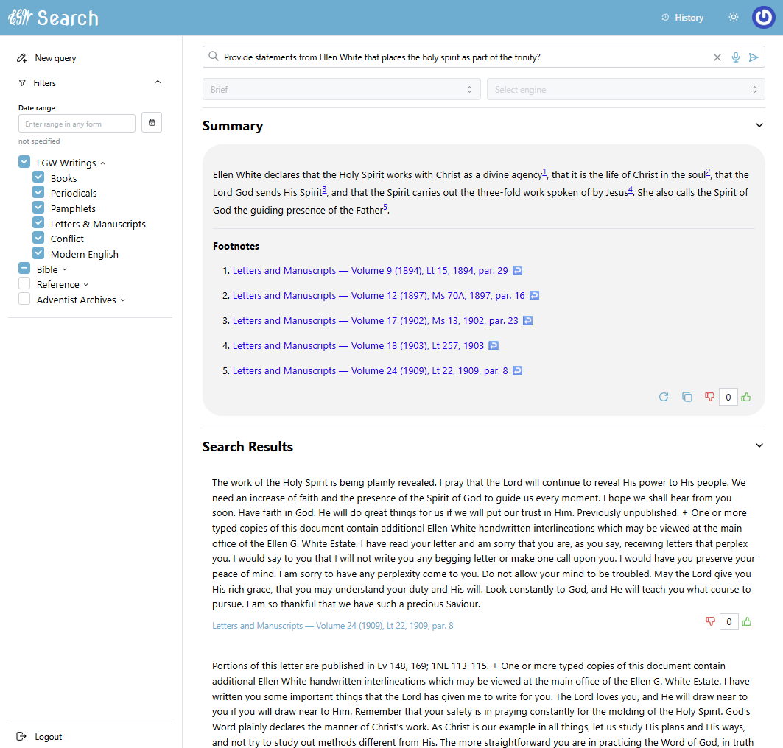

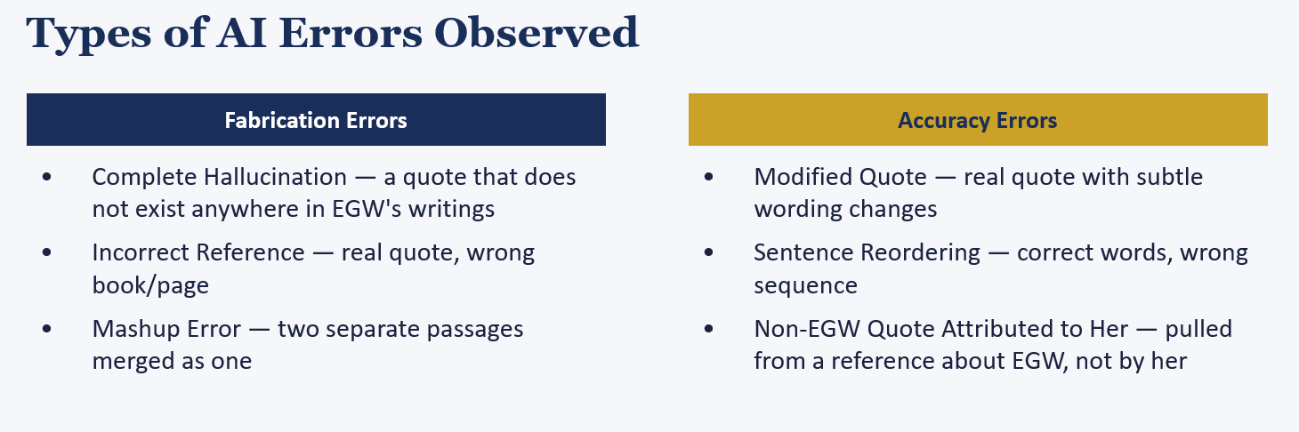
All general-purpose Artificial Intelligence models, however capable they may be in other areas of study, are not — at least not yet, until Artificial General Intelligence (AGI) is achieved — be trusted.

This research paper has shown that you cannot rely 100% on any AI models to do research in the writings of Ellen White. All AI results must be verified by human oversight, carefully comparing their answers to the authoritative source — EGWWritings.org.

